Lab 8: Input Validation
This lab accompanies Chapter 7 of Starting Out with Programming Logic & Design.

Name: ___________________________

Lab 8.1 – Input Validation

Critical Review

If a computer reads bad data as input, it will produce bad data as output. Programs should be designed to reject bad data that is given as input.

Garbage in, garbage out (GIGO), refers to the fact that computers cannot tell the difference between good data and bad date.

Both numbers and strings can be validated.

Help Video: View lab video 8.1a

The goal of this lab is to identify potential errors with algorithms and programs.
LSCNH-Official Worksheet
Step 1: Imagine a program that calls for the user to enter a password of at least 14 alphanumeric characters. Identify at least two potential input errors.
Shorter than 14 characters
Non-alphanumeric characters

Step 2: Imagine a program that calls for the user to enter patients’ cholesterol. Cholesterol ranges are 150 to 250. Identify at least two potential input errors.
Number outside of bounds
Non-number characters

Step 3: Open either your Lab 5-3.rap flowchart or your Lab 5-4.py Python code. This program allowed the user to enter in 7 days of employee deployments and then calculated the total. Examine the program and identify at least two potential input errors.
Entering in letters
Entering in nothing

Step 4: Open either your Lab 6-4.rap flowchart or your Lab 6-4.py Python code. This program allowed a user to calculate their weekly pay to include overtime. Examine the program and identify at least two potential input errors.
_______________________________________________________________________
_______________________________________________________________________
Lab 8.2 – Input Validation and Pseudocode

Critical Review

Input validation is commonly done with a loop that iterates as long as an input variable contains bad data. Either a posttest or a pretest loop will work. If you want to also display an error message, use a pretest loop, otherwise, a posttest loop will work.

Functions are often used for complex validation code.

Help Video: View Lab video 8.2a

The goal of this lab is to write input validation pseudocode.
LSCNH-Official Worksheet
Step 1: Examine the following main module from Lab 5.2. Notice that if the user enters a capital ‘Y’ the program will end since the while loop only checks for a lower case ‘y’.

Module main ()

//Step 1: Declare variables below
Declare Integer totalEmployees = 0
Declare Integer counter = 1
Declare Integer todayEmployees = 0
Declare Real totalPayout
Declare String runProgram = ‘y’

//Step 3: Loop to run program again
While runProgram == ‘y’
//Step 2: Call functions
getEmployees(totalEmployees, todayEmployees, counter)
calcPayout(totalEmployees, totalPayout)
printInfo(totalEmployees, totalPayout)

Display “Do you want to run the program again? (Enter y for yes or n for no).”
Input runProgram
End While
End Module
LSCNH-Official Worksheet
Step 2: Write a line of code that will convert the input value to an upper case value. (See Lab 8.2 supplement, lab 8 section in D2L).
RunProgram.upper()

Step 3: Examine the getEmployees module from the same program. Notice the potential input error of the user entering a negative value into todayEmployees. Rewrite the module with an input validation loop inside the existing while loop that will verify that the entry into todayEmployees is greater than 0. If they enter a 0 or negative value, display an error message. (Reference: Input Validation Loop, Page 268).
LSCNH-Official Worksheet
Previous Code
//getEmployees module
Module getEmployees (Integer totalEmployees, Integer todayEmployees, Integer counter)
While counter <=7
Display “Enter number of employees sent out for the day:”
Input todayEmployees
totalEmployees = totalEmployees + todayEmployees
counter = counter + 1

End While
End Module

Validation Code
//getEmployees module
Module getEmployees (Integer totalEmployees, Integer todayEmployees, Integer counter)
While counter <=7
while todayEmployees <= 0:
display “Enter a number greater than 0”
Display “Enter number of employees sent out for the day:”
Input todayEmployees
_______________________________________________
totalEmployees = totalEmployees + todayEmployees
counter = counter + 1
End While
End Module

Step 4: Examine the following pseudocode from Lab 6.4. Rewrite the module with a validation loop so that no less than 2 weeks and no more than 12 weeks are calculated.
LSCNH-Official Workshee
Previous Code

Module getWeeks(Integer Ref weeks)
Display “How many weeks would you like to calculate pay for?: ”
Input weeks
End Module

Validated Code

Module getWeeks(Integer Ref weeks)

______________________________________________________
______________________________________________________
______________________________________________________
______________________________________________________
______________________________________________________
End Module

Step 5: Examine the following pseudocode from Lab 6.4. Rewrite the module with a validation loop so that the hours worked must be between 0 and 84.
LSCNH-Official Workshee
Previous Code

Module getPay(Real Ref totalPay, Integer weeks, Real wage, Real hours, Integer counter)
For counter = 1 to weeks
Display “Enter the week “, counter, “ hours:”
Input hours
Set totalPay = totalPay + (hours * wage)
if hours > 40 then
Set totalPay = totalPay + ((hours – 40) * (wage / 2))
end if
End For
End Module

Validated Code
LSCNH-Official Workshee
Module getPay(Real Ref totalPay, Integer weeks, Real wage, Real hours, Integer counter)
______________________________________________________
______________________________________________________
____________________________________________________________________________________________________________
______________________________________________________
______________________________________________________
End Module

Lab 8.3 – Functions and Flowcharts

Critical Review

Based on the type of loop used for validation, you may have noticed the concept of a priming read. This is this the first input before the validation loop.

The purpose of this is to get the first input value that will be tested by the validation loop.

A priming read is used with a while loop, rather than a do-while loop.

Note: If the programmer is asking for a particular type of input (either numeric or string), the user is free to enter something else. This will normally cause a fatal error at some point of program execution. Avoiding these fatal errors is beyond the scope of basic Raptor programming. What this means is that all errors cannot be resolved using Raptor.

Help Video: View lab video 8.3a

This lab requires you to modify the flowchart from Lab 6-4.rap to incorporate validation loops. Use an application such as Raptor or Visio.
LSCNH-Official Workshee
Step 1: Start Raptor and open your flowchart from Lab 6-4.rap. Go to File and then Save As and save your document as Lab 8-3. The .rap file extension will be added automatically.
LSCNH-Official Workshee
Step 2: In the main module, modify your loop condition so that the user must enter a “yes” or a “no” value. This can be done with nested Loop symbols. Your flowchart might look as follows:
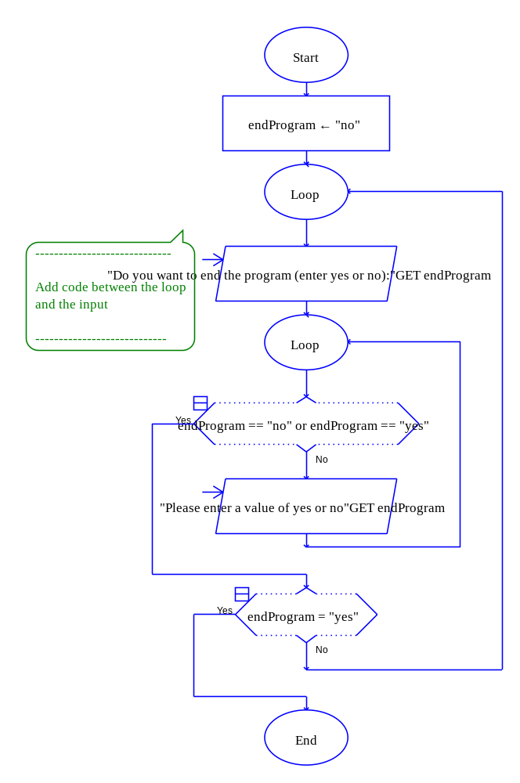
PASTE FLOWCHART HERE

Step 3: In the getWeeks module, modify the code so that the input must be at least 2 or more weeks and no more than 12 weeks. If the user enters a valid number, the program should continue. If not, display an error message that says “Please enter a number between 2 and 12 – Try again!!” Use a prime read in this situation. Paste your getWeeks module flowchart in the space below.

PASTE FLOWCHART HERE
LSCNH-Official Workshee
Step 4: In the getWage module, modify the code so that the input must be between 7.25 and 29.95. If the user enters a valid number, the program should continue. If not, display an error message that says “Please enter a number between 7.25 and 29.95 – Try again!!” Use a prime read in this situation. Paste your getWage module flowchart in the space below.
LSCNH-Official Workshee
PASTE FLOWCHART HERE
Lab 8.4 – Python Code and Input Validation
Critical Review

Numeric validation loops in Python are done by writing the types of loops you already are familiar with. Code using a prime read might look as follows:

number = input('Enter a number between 1 and 10: ')
while number < 1 or number > 10:
print 'Please enter a number between 1 and 10'
number = input('Enter a number between 1 and 10: ')

Validation code for string input uses the not keyword to check the opposite of something. Code using a prime read might look as follows:

endProgram = raw_input('Do you want to end program? (Enter no or yes): ')
while not (endProgram == 'yes' or endProgram == 'no'):
print 'Please enter a yes or no'
endProgram = raw_input('Do you want to end program? (Enter no to process a new set of scores): ')

Help Video: View lab video 8.4a

The goal of this lab is to convert the Pay Calculator program in Lab 8.3 to Python code.
LSCNH-Official Workshee
Step 1: Start the IDLE Environment for Python. Open your Lab6-4.py program and click on File and then Save As. Select your location and save this file as Lab8-4.py. Be sure to include the .py extension.

Step 2: Modify the documentation in the first few lines of your program to include your name, the date, and a brief description of what the program does to include validation.

Step 3: Modify the main function so that the user must enter either a ‘yes’ or ‘no’ value in order for the loop to continue. Use a prime read and a while loop with an error message if a bad number is entered.
LSCNH-Official Workshee
Step 4: Modify the getWeeks function so that the user must enter a number between 2 and 12. Use a prime read and a while loop with an error message if a bad number is entered.

Step 5: Modify the getWage function so that the user must enter a number between 7.25 and 29.99. Use a prime read and a while loop with an error message if a bad number is entered.
LSCNH-Official Workshee
Step 6: Execute your program so that all error code works and paste final code below:
LSCNH-Official Workshee
PASTE CODE HERE

Lab 8.5 – Programming Challenge 1 – Cell Phone Minute Calculator

Write the Flowchart and Python code for the following programming problem based on the pseudocode below.
LSCNH-Official Workshee
Help Video for Raptor: View video: Raptor 8.5

Help Video for Python: View video: Python 8.5

Design and write a program that calculates and displays the number of minutes over the monthly contract minutes that a cell phone user incurred. The program should ask the user how many minutes were used during the month and how many minutes they were allowed. Validate the input as follows:

- The minimum minutes allowed should be at least 200, but not greater than 800. Validate input so that the minutes allowed are between 200 and 800.
- The minutes used must be over 0. Validate input so that the user does not enter a negative value.

Once correct data is entered, the program should calculate the number of minutes over the minute allowed. If minutes were not over, print a message that they were not over the limit. If minutes were over, for every minute over, a .20 fee should be added to the monthly contract rate of 74.99. Be sure not to add the .20 fee for minutes 1 to the number of minutes allowed, but rather just minutes over. Display the number of minutes used, minutes allowed, the number of minutes over, and the total due that month.

You might consider the following functions:
- A function that allows the user to enter in minutes allowed within the range of 200 and 800.
- A function that allows the user to enter in the minutes used greater than or equal to 0.
- A function that calculates the total due and the total minutes over.
- A function that prints a monthly use report.

Your sample output might look as follows (note the validation code):

Sample 1 Showing Validation:
LSCNH-Official Workshee
How many minutes are allowed: 1000
Please enter minutes between 200 and 800
How many minutes are allowed: 801
Please enter minutes between 200 and 800
How many minutes are allowed: 350
How many minutes were used: -10
Please enter minutes used of at least 0
How many minutes were used: 400

You were over your minutes by 50

---------------MONTHLY USE REPORT------------------

Minutes allowed were 350
Minutes used were 400
Minutes over were 50
Total due is $ 84.99

Do you want to end program? (Enter no or yes): NO
Please enter a yes or no
Do you want to end program? (Enter no or yes): 9
Please enter a yes or no
Do you want to end program? (Enter no or yes): no
LSCNH-Official Workshee
Sample 2 Showing Minutes Over:

How many minutes are allowed: 600
How many minutes were used: 884

You were over your minutes by 284

---------------MONTHLY USE REPORT------------------

Minutes allowed were 600
Minutes used were 884
Minutes over were 284
Total due is $ 131.79

Do you want to end program? (Enter no or yes): no

Sample 3 Showing Minutes Not Over:

How many minutes are allowed: 400
How many minutes were used: 379

You were not over your minutes for the month

---------------MONTHLY USE REPORT------------------

Minutes allowed were 400
Minutes used were 379
Minutes over were 0
Total due is $ 74.99

Do you want to end program? (Enter no or yes): yes
LSCNH-Official Workshee
The Pseudocode

Module main()
//Declare local variables
Declare String endProgram = “no”
While (endProgram == “no”
Declare Integer minutesAllowed = 0
Declare Integer minutesUsed = 0
Declare Real totalDue = 0
Declare Integer minutesOver = 0

//calls functions
Set minutesAllowed = getAllowed(minutesAllowed
Set minutesUsed = getUsed(minutesUsed
Set totalDue, minutesOver = calcTotal(minutesAllowed, minutesUsed, totalDue, minutesOver)
Call printData(minutesAllowed, minutesUsed, totalDue, minutesOver)
Display “Do you want to end program? yes or no”
Input endProgram
While endProgram != “yes” or endProgram != “no”
Display “Please enter yes or no”
Display “Do you want to end program? yes or no”
Input endProgram
End While
End While
End Module

Function Integer getAllowed(Integer minutesAllowed)
Display “How many minutes are allowed”
Input minutesAllowed
While minutesAllowed < 200 OR minutesAllowed > 800
Display “Please enter minutes between 200 and 800”
Display “How many minutes are allowed”
Input minutesAllowed
End While
Return minutesAllowed
End Function

Function Integer getUsed(Integer minutesUsed)
Display “How many minutes were used”
Input minutesUsed
While minutesUsed < 0
Display “Please enter minutes of at least 0”
Display “How many minutes were used”
Input minutesUsed
End While
Return minutesUsed
End Function

Function Real Integer calcTotal(Integer minutesAllowed, Integer minutesUsed, Real totalDue, Integer minutesOver)
Real extra = 0
If minutesUsed <= minutesAllowed then
Set totalDue = 74.99
Set minutesOver = 0
Display “You were not over your minutes for the month”
Else
Set minutesOver = minutesUsed – minutesAllowed
Set extra = minutesOver * .20
Set totalDue = 74.99 + extra
Display “You were over your minutes by”, minutesOver
End If
Return totalDue, minutesOver
End Function

Module printData (Integer minutesAllowed, Integer minutesUsed, Real totalDue, Integer minutesOver)
Display “----------------MONTHLY USE REPORT----------------------“
Display “Minutes allowed were”, minutesAllowed
Display “Minutes used were”, minutesUsed
Display “Minutes over were”, minutesOver
Display “Total due is $”, totalDue
LSCNH-Official Workshee
The Flowchart LSCNH-Official Workshee

PASTE FLOWCHART HERE

The Python Code LSCNH-Official Workshee

PASTE CODE HERE

